|  |  |
| --- | --- |
| Whitireia Logo_2010 | **Faculty of Business and Information Technology** |

**Bachelor of Information Technology**

**IT5x83 Fundamentals of**

**Software Design and Development**

**Assignment One**

**Preliminary Investigation Report**

**Author:** Taylor Everett

**STU ID:** 21600252

**Date**: Friday 9th September 2016

Table of Contents

[**Executive Summary** 2](#_Toc460835328)

[**Introduction** 3](#_Toc460835329)

[**Project Scope and Constraints** 3](#_Toc460835330)

[Scope 3](#_Toc460835331)

[Constraints 4](#_Toc460835332)

[**Fact-Finding** 4](#_Toc460835333)

[Risks 4](#_Toc460835334)

[Constraints 5](#_Toc460835335)

[Scope 5](#_Toc460835336)

[Scalability Issues 5](#_Toc460835337)

[**Rich Picture** 5](#_Toc460835338)

[**Analysis of Project** 6](#_Toc460835339)

[Project Roles 6](#_Toc460835340)

[Work Breakdown Structure 8](#_Toc460835341)

[Gantt Chart 9](#_Toc460835342)

[PERT/CPM Chart 9](#_Toc460835343)

[**Evaluate Feasibility** 10](#_Toc460835344)

[**Conclusion** 10](#_Toc460835345)

[**Recommendation** 11](#_Toc460835346)

# Executive Summary

In this Preliminary Report, the project “Dream Getaways Resort” website will be scoped in its entirety to our understanding. Among the listed scope are constraints and results of our interviews labelled fact-finding which gives a brief summary into risks, constraints, scope, and scalability issues. An analysis of the project displays those who are involved and under “project roles” a breakdown of the necessary work along scheduling through a Gantt chat followed by a PERT/CPM chart. The project is then evaluated for feasibility and followed by a conclusion then recommendations for further upgrades and advancements.

# Introduction

Dream Getaways is a tourism business who owns a resort running a manual check-in and experience system using forms and would like a website for their business that involves a booking systems for customers checking into their resort hotel. The new system should cater when customers intend to arrive and how long they will be staying as well as the types of rooms they will be staying in such as single, shared or double room sizes.

We have received a request from Dream Getaways Resort requesting that we design and create a website to promote the company’s activities. The new system will also allow the customers to organise their experience plans such as attending biking, hiking and canoeing events as well as tending to departure plans of their customers providing shuttle services where required. Initially we need to produce a preliminary Investigation Report to determine if Dream Getaways Resort request is feasible and to set out some initial project planning requirements.

# Project Scope and Constraints

## Scope

* Create a website that can be used to promote the business and allow users to create bookings.
* A home page with information about the resort.
* An about us page
* Booking page
* Restaurant page
* Experience page and the activities provided.
* A contact us page which must include an email enquire form and a map of the resorts location.
* Company Colours are light purple and eco green.
* Dream Getaways Resort now has an ISP and necessary Hardware (computers) to have interaction with the website.
* Links to facebook.com and twitter

## Constraints

* Client system training will be required
* Limiting access to key users
* Made as soon as possible
* No current Tech support
* Don’t know if all staff have SMART phones

# Fact-Finding

## Risks

Dream Getaways Website would have to be tolerable for the general public to ensure an enjoyable experience for the users otherwise it may alienate them to the point where they may no longer want to stay at the resort. Staff may not check incoming information leading to frustrated clients if information isn’t processed correctly or in a timely manner. Like all websites it be subjected to limitations to have the internet running to have function and access and may have unwanted Users that may try and do harm.

## Constraints

Dream Getaways website will have restricted access to who can make changes and updates. This is favourable due to risks. Biggest constraint would have to be training for staff to use a new system which will have to depend on staffs’ computer skills prior to. Scheduling should be made as soon as possible as the client would like to be functional and have something to see to ensure his company is being promoted correctly.

## Scope

Dream Getaways wants a website to help promote themselves while adding a booking system that can also accept payment. Found that it needs a total of six pages Home, About, Restaurant, Experiences, Booking and Contact Page. Of the pages listed, the client would like access restrictions where the Manager has full access, Chef has access limited to the Restaurant page, and Experiences staff has access limited to the Experiences page to make changes. Can begin as soon as possible when Preliminary Report has been accepted and Design stage may start when logo and company colours are provided by the client.

## Scalability Issues

Scalability will have to depend on the resources of the business which can limit the functions of the website such as Scaling to mobile devises, User panel, Maintenance, Booking Engine, and maybe the number of pages. Cost may be reduced if Client where to set up their own social media accounts.

# Rich Picture

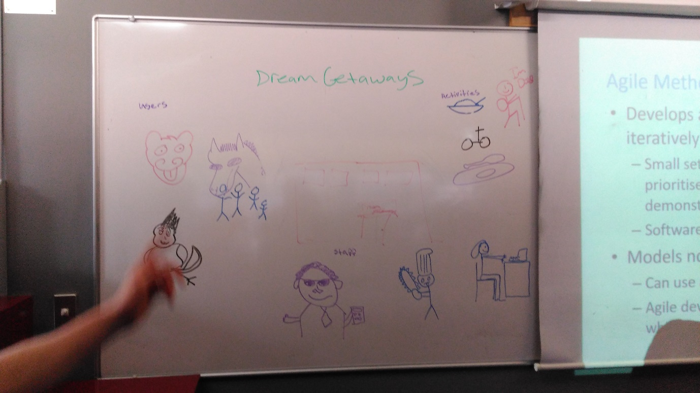

# Analysis of Project

## Project Roles

JAB Team - Interviews the client as well as provides feedback for determining the scope and constraints of the project. Also creates the proposal if accepted.

Project Manager – Sets the scheduling and makes sure all aspects of the project are running on time and provide solutions if needed.

Development Team - Designs, implements, tests the finished project to the abstract of the proposal.

Dream Getaways owner- Funding and organizing with JAB team to reach a fine the scope of the project.

Administration - Will only be able to view the website, not part of the website process.

Resort Manager – Will have full access of the website for the day to day operations.

Chef – Will have restricted access to the restaurant page only to make changes to the menu.

Experience Staff – Will have restricted access to the Experiences page to change and display new events and offerings of service.

Reception- Will only be able to view the website to check pricing differences.

Accountant - Will only be able to view the website but will also receiving booking details to manage company accounts.

USERS - Will only be able to view the website and make bookings.

House Keepers - Will only be able to view the website, not part of the website process.

## Work Breakdown Structure

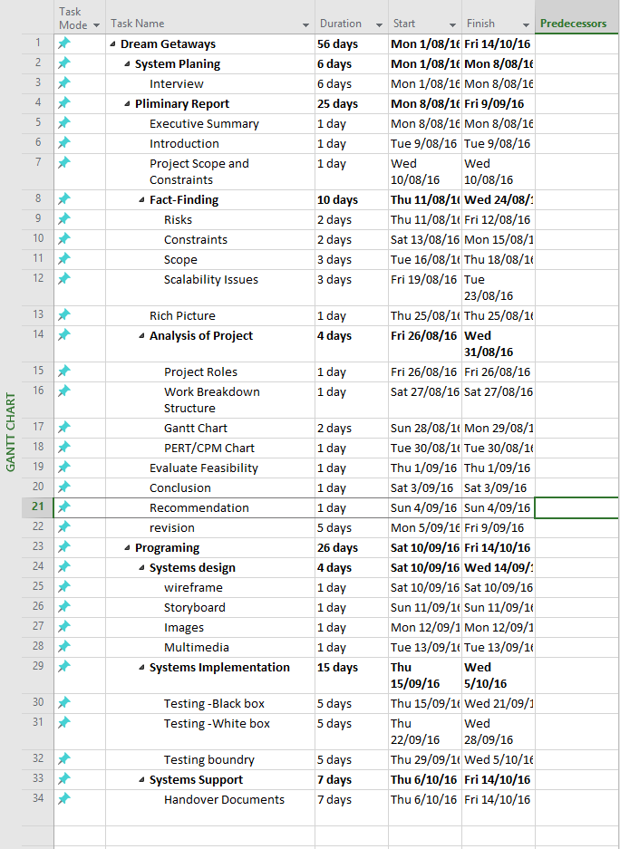

## Gantt Chart

**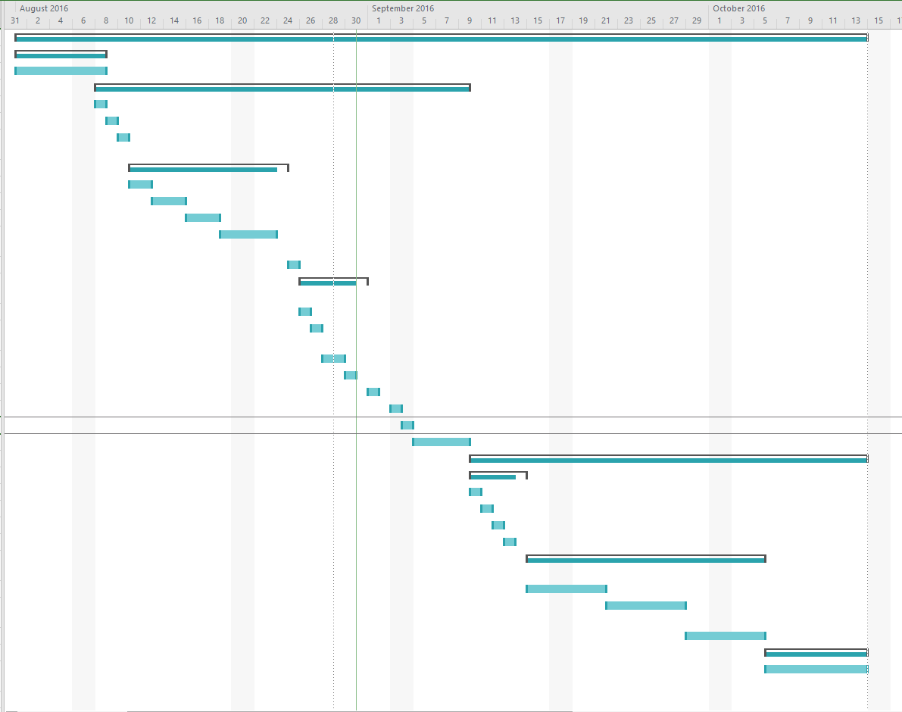**

## PERT/CPM Chart

Preliminary Report

|  |  |  |  |
| --- | --- | --- | --- |
| Start | 6 | ID | 4 |
| Finish | 31 | Dur | 25 |

System Planning

|  |  |  |  |
| --- | --- | --- | --- |
| Start | 1 | ID | 2 |
| Finish | 6 | Dur | 6 |

System Design

|  |  |  |  |
| --- | --- | --- | --- |
| Start | 31 | ID | 24 |
| Finish | 35 | Dur | 4 |

System Testing

|  |  |  |  |
| --- | --- | --- | --- |
| Start | 36 | ID | 29 |
| Finish | 60 | Dur | 15 |

Programming

|  |  |  |  |
| --- | --- | --- | --- |
| Start | 31 | ID | 23 |
| Finish | 57 | Dur | 26 |

# Evaluate Feasibility

In regards to be operational, the website should be able to promote, if not entice, new users to come and visit Dream Getaways Resort as well as take bookings and payments. Technically having a website is a necessity for any business looking to expand on their current demographic since the internet is so commonly used this day and age. The cost of having a website is nearly a onetime spend since it only has to be made once and can all ways be modified or upgraded at a later date. The Client “Dream Getaways Resort “would have to set up scheduling to when the website gets checked because once the website goes live it cannot be neglected.

# Conclusion

Dream Getaways Resort is a popular and thriving business who is looking for a way to be number one in its area and their solution is to obtain a website, that I believe we can provide. This would open them up to a new untapped market of ecommerce with a vastly growing population via internet. By having a website, they can lower physical documentation and could even speed up processing time by simplifying their forms to a digital format. Through the scope of this report it is made obvious that this website they intend to obtain would greatly promote and sell this business being more intuitive and active with its updates to experiences page and the menu for the restaurant page. In conclusion the Dream Getaways website would be a powerful tool to expand Dream Getaways Resort’s present situation as they see fit.

# Recommendation

Further computer training to help staff understand basics on computer usage such as printing and simple trouble shooting. An addition of a functional “User Panel” for the website so the administrator/owner can have oversight and options to change and edit permission of other staff members. Addition of an on-site database and server for handling future computer needs that may arise such as back-ups, Wi-Fi controllers, and personal database to have an alternative spread sheet. Additional maintenance service that would allow IT support if the website where to have any unforeseen complications or to solve any compatibility problems with change of hardware/software like upgrading operation systems. Registering with other online booking engine sites to expand to a market place which has paid advertisement making them an additional way to find your resort.